

Project Report

EXCEL ON CONSULTING SERVICES



TEAM MEMBERS

1. **Muskan Malik**
2. **Sohaib Khan**
3. **Muhammad Farhad**

#### Table of Contents

Introduction ……………………………………………………………………………...02

Existing Scenario ……………………………………………………………………….02

Proposed Scenario ……………………………………………………………………….02

Non-Financial ….……………………………………………………………….03

Financial.……………………………………………………………………….04

Functional Requirements ……………………………………………………………….04

Introduction

Excell-on Consulting Services (ECS) helps organizations develop innovative business and commerce strategies and solutions. These solutions allow their (organizations, say clients of Excell-on Consulting Services) customers to capitalize on new technologies to create innovative products and services for the economy. Their consulting team stays focused on defining, optimizing, and aligning their client’s business and IT strategies.

***Existing Scenario:*** *–*

Excell-on has segregated themselves into various branches based on the various services that they offer to their clients, so as to meet the requirements of organizations i.e., of their clients. The various branches that the Excell-on had segregated is as follows:

1. In-bound Services (The In-bound service is a service in which one can only receive the calls from the customers. These call centers provide 24 hours service to all customers. The primary goal of these call centers are to receive product orders, help customers both technically and non-technically, to find dealer location.)
   * Technical Support
   * Customer Service
2. Out-bound Services (The Out-bound service is a service in which the employees of Excell-on call the customers for product promotions, for checking with the customer satisfaction on the services they provide, and for the telemarketing. Outbound Call Centers depends on the technological solutions, extensive experience, quality assurance programs and commitment to customer service excellence that further ensures maximum results from the direct marketing efforts for its success.)
3. Tele Marketing Services (The Tele Marketing service is a service which is purely for the promotion of marketing or sales of the products and services.)

***Proposed Solution:*** –

As the Internet and the web being the growth engines of the new millennium, the management had decided to maintain the details of their services and that of their clients along with the services that they (clients of Excell-on) prefer, payment details. So they want an online application to be introduced into their system through which they can keep track of the services they provide, their clients, type of service that their client had preferred, and the products and the procedures of their clients and the details of the customers, and the call logs.

So, they had approached us in order to help them by creating a web application for them meeting their requirements. The application should hold the following functionalities.

**►Non-Financial:**

1. The details of the services offered are to be maintained.
2. The different department details are to be maintained. The different departments that Excell-on has is as follows
   * HR Management
   * Administration
   * Service
   * Training
   * Internet Security (It will take care of any technical related issues and problems like PC of an employee is hanged, PC of an employee is not getting started, one of the software applications is not running properly, installing and uninstalling software, etc.)
   * Auditors
3. The details of the employees are to be maintained based on the designation and the services (like out-bound, in-bound, etc.)
4. The details of the charges levied for each service are to be maintained.
5. The details of the clients are to be maintained.
6. The details of the services that their clients preferred are to be maintained.
7. The details of the products and services that their clients offer (like if the client is a manufacturer of refrigerators, then the details of the different type of refrigerator they manufacture are to be maintained, and if the client is the internet service provider, then the details like the various type of the services that they offer, and they want Excell-on to promote the sales services for that company using the in-bound or out-bound services, then these details are to be maintained, etc.) are to be maintained.
8. Based on the charges levied for a service, the total charges for the clients are to be calculated based on the services that the client prefers.
9. The details of the payments as received by the client are to be maintained.
10. The reports for the late payments, payments, clients, employees based on the services, for a particular duration are to be generated

**►Financial:**

The charges for the different services that they offer keep on varying based on the services preferred by their clients. The charge structure for the services that the Excell-on offers is as follows.

|  |  |  |
| --- | --- | --- |
| **Sr. No**. | **Service** | **Charges (per day per employee)** |
| 1 | In-bound | 4500$ |
| 2 | Out-bound | 6000$ |
| 3 | Tele Marketing | 5500$ |

***Functional Requirements: –***

1. The database should contain the details of the services, department details, employee details, client details, the details of the services that are preferred by the clients, the product details of the clients, the payment details that are paid by the clients of Excell-on.
2. One should be able to maintain the details of the charges levied for each type of service.
3. One should be able to insert, update, delete and search and retrieve the records of the clients.
4. The advanced search option is to be implemented so as to fetch and retrieve the records.

# **3. Project Plan**

The project plan for the Doctors Excel on Consulting Services is briefly defined below in tables:

|  |  |  |  |
| --- | --- | --- | --- |
| Object | Start Date | End Date | Time |
| Web-Application | | | |
| Brand Logo | 9 July 2023 | 9 July 2023 | 30 Mins |
| Navigation | 9 July 2023 | 9 July 2023 | 1 Hour |
| Page Slider | 9 July 2023 | 9 July 2023 | 1 Hour |
| Page Footer | 9 July 2023 | 9 July 2023 | 1 Hour |
| Member Login | 10 July 2023 | 12 July 2023 | 2 Hour |
| Member Registration | 10 July 2023 | 10 July 2023 | 2 Hours |
| Login, Logout | 10 July 2023 | 10 July 2023 | 1 Hour |
| Member Profile | 10 July 2023 | 10 July 2023 | 3 Hours |
| Member Profile’s Privacy Work | 10 July 2023 | 10 July 2023 | 2 Hours |
| Home | 13 July 2023 | 13 July 2023 | 1 Hour |
| About | 13 July 2023 | 13 July 2023 | 1 Hour |
| Services | 13 July 2023 | 14 July 2023 | 1 Hour |
| Training | 15 July 2023 | 15 July 2023 | 1 Hour |
| Contact | 15 July 2023 | 16 July 2023 | 1 Hour |
| Web Forum | 16 July 2023 | 16 July 2023 | 4 Hours |
| Search Bar | 16 July 2023 | 16 July 2023 | 2 Hours |
| Dashboard | | | |
| Data Base | 17 July 2023 | 17 July 2023 | 1 Hour |
| Dashboard Theme Setup | 17 July 2023 | 17 July 2023 | 2 Hour |
| Admin Login | 17 July 2023 | 17 July 2023 | 2 Hour |
| Login, Logout Sweet Alerts | 18 July 2023 | 18 July 2023 | 1 Hour |
| Branches | 18 July 2023 | 18 July 2023 | 1 Hour |
| Index | 18 July 2023 | 18 July 2023 | 1 Hour |
| Services | 18 July 2023 | 18 July 2023 | 1 Hour |
| Inbound services | 19 July 2023 | 19 July 2023 | 1 Hour |
| Inbound services | 19 July 2023 | 19 July 2023 | 1 Hour |
| Telemarketing services | 19 July 2023 | 19 July 2023 | 1 Hour |
| Address Management | 20 July 2023 | 20 July 2023 | 1 Hour |
| Dashboard Counts | 22 July 2022 | 22 July 2022 | 30 Mins |

**4. E-R**

**5.Diagram**

This Figure below displays the ER diagram for Excel on Consulting Services.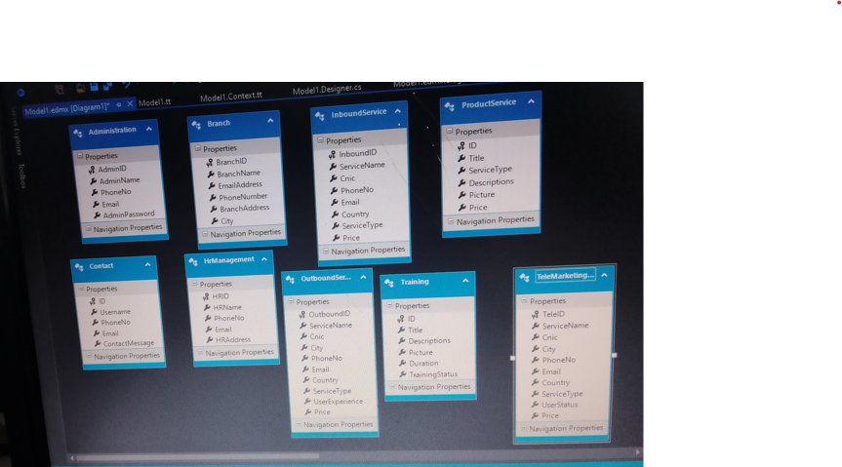

# **6. Algorithms**

The algorithm structure of different tables is given in the following sections:

|  |
| --- |
| **Table: Admin** |

|  |  |  |  |
| --- | --- | --- | --- |
| **Field Name** | **Data Type** | **KEY** | **Description** |
| Id | Integer |  | Stores the unique ID of the admin table (auto-generated unique identifier of this table) |
| Name | Varchar |  | Stores the name of the admin |
| Email | Varchar |  | Stores the email of the admin |
| Phone | Varchar |  | Stores the phone number of the admin |
| Gender | Varchar |  | Stores the password of the admin |
| Password | Varchar |  | Stores the password of the admin |

|  |
| --- |
| **Table: Branches** |

|  |  |  |  |
| --- | --- | --- | --- |
| **Field Name** | **Data Type** | **KEY** | **Description** |
| Id | Integer |  | Stores the unique ID of the tbl_slider (auto-generated unique identifier of this table) |
| Branch Name | Varchar |  | Stores the Web-Application slider’s title |
| Email Address | Varchar |  | Stores the Web-Application slider’s sub-title |
| Phone Number | Varchar |  | Stores the Web-Application slider’s button title |
| city | Varchar |  | Stores the Web-Application slider’s branch city. |

|  |
| --- |
| **Table: Services** |

|  |  |  |  |
| --- | --- | --- | --- |
| **Field Name** | **Data Type** | **KEY** | **Description** |
| Id | Integer |  | Stores the unique ID of the tbl_services (auto-generated unique identifier of this table) |
| Titles | Varchar |  | Stores the Web-Application services title |
| Descriptions | Varchar |  | Stores the Web-Application services description |
| Picture | Varchar |  | Stores the Web-Application services picture |
| Price | Varchar |  | Stores the Web-Application services price |

|  |
| --- |
| **Table: Inbound services** |

|  |  |  |  |
| --- | --- | --- | --- |
| **Field Name** | **Data Type** | **KEY** | **Description** |
| Id | Integer |  | Stores the unique ID of the tbl_appointment (auto-generated unique identifier of this table) |
| Title | Varchar |  | Stores the Web-Application Appointments user name |
| Service Type | Varchar |  | Stores the Web-Application Appointments user email |
| Description | Varchar |  | Stores the Web-Application Appointments date |
| Picture | Varchar |  | Stores the Web-Application Appointments time |
| Price | Varchar |  | Stores the Web-Application Appointments department |

|  |
| --- |
| **Table: Outbound Services** |

|  |  |  |  |
| --- | --- | --- | --- |
| **Field Name** | **Data Type** | **KEY** | **Description** |
| Id | Integer |  | Stores the unique ID of the tbl_gallery (auto-generated unique identifier of this table) |
| services Name | Varchar |  | Stores the Web-Application service NAME |
| CNIC | Varchar |  | Stores the Web-Application CNIC |
| Phone Number | Varchar |  | Stores the Web-Application Phone number |
| Email | Varchar |  | Stores the Web-Application Email |
| Country | Varchar |  | Stores the Web-Application Country |
| Service Type | Varchar |  | Stores the Web-Application SERVICETYPE |
| Price | Varchar |  | Stores the Web-Application PRICE |

|  |
| --- |
| **Table: Telemarketing services** |

|  |  |  |  |
| --- | --- | --- | --- |
| **Field Name** | **Data Type** | **KEY** | **Description** |
| Id | Integer |  | Stores the unique ID of the tbl_address (auto-generated unique identifier of this table) |
| services Name | Varchar |  | Stores the Web-Application address services name |
| CNIC | Varchar |  | Stores the Web-Application adder cnic |
| Phone Number | Varchar |  | Stores the Organization official phone number |
| Email | Varchar |  | Stores the Web-Application Email |
| Country | Varchar |  | Stores the Web-Application address country |
| Service Type | Varchar |  | Stores the Web-Application address services type |
| Price | Varchar |  | Stores the Web-Application address price |

|  |
| --- |
| **Table: HR Management** |

|  |  |  |  |
| --- | --- | --- | --- |
| **Field Name** | **Data Type** | **KEY** | **Description** |
| Id | Integer |  | Stores the unique ID of the tbl_doctors (auto-generated unique identifier of this table) |
| Name | Varchar |  | Stores the Web-Application doctor’s name |
| Address | Varchar |  | Stores the Web-Application Address |
| Phone number | Varchar |  | Stores the Web-Application phonenumber |
| Email | Varchar |  | Stores the Web-Application Email |
| Password | Varchar |  | Stores the Web-Application password |

|  |
| --- |
| **Table: Administration** |

|  |  |  |  |
| --- | --- | --- | --- |
| **Field Name** | **Data Type** | **KEY** | **Description** |
| Id | Integer |  | Stores the unique ID of the tbl_contact (auto-generated unique identifier of this table) |
| Name | Varchar |  | Stores the Web-Application user’s name |
| Email | Varchar |  | Stores the Web-Application user’s email |
| Phone | Varchar |  | Stores the Web-Application user’s phone number |

|  |
| --- |
| **Table: Training** |

|  |  |  |  |
| --- | --- | --- | --- |
| **Field Name** | **Data Type** | **KEY** | **Description** |
| Id | Integer | **PK** | Stores the unique ID of the tbl_queries (auto-generated unique identifier of this table) |
| name | Varchar |  | Stores the name of the user who posted a query |
| Services Type | Varchar |  | Stores the queries of the user who posted a query |
| user image | Varchar |  | Stores the profile of the user who posted a query |

# **6. GUI Standard Documents**



GUI Standard Document includes all the Administrator dashboard activities.

## **Administrator Activities**

Admins Separate Login Page.

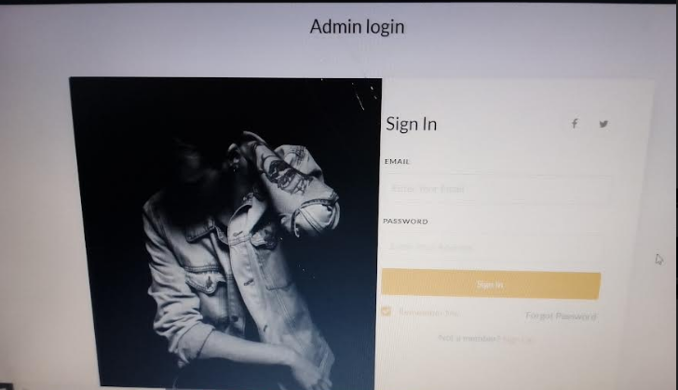

After Logged in admin can view dashboard counts of total users, total services, HRManagement and training all these cards are working dynamically.

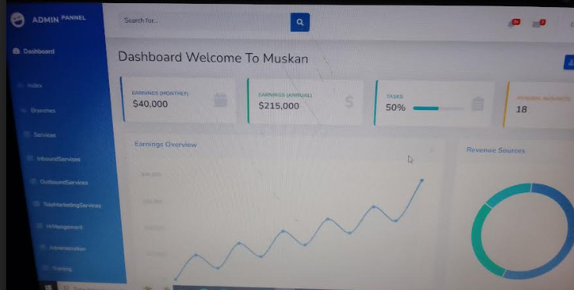

* Admin can view and remove user’s account

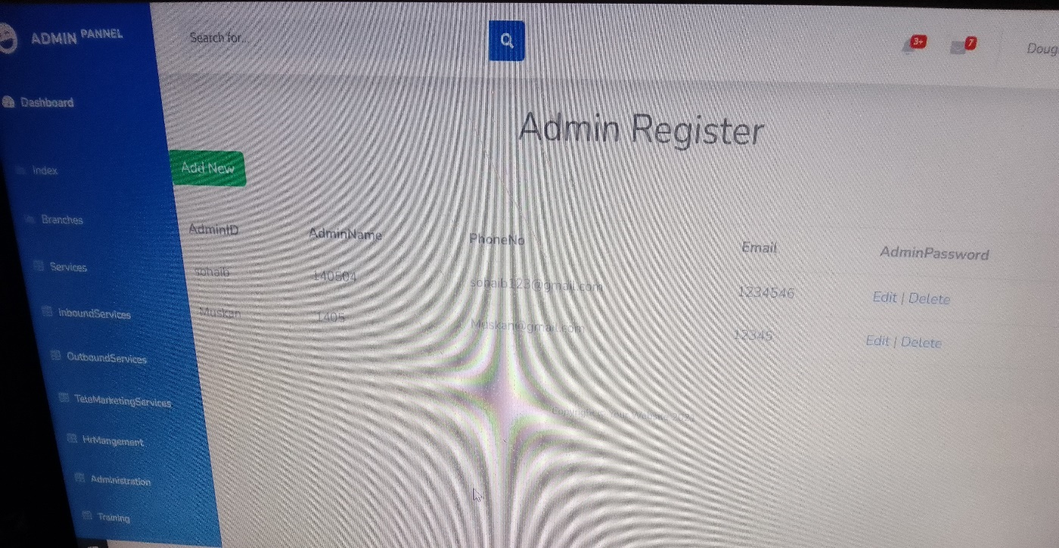

* Admin can manage the Branches of the web-application.

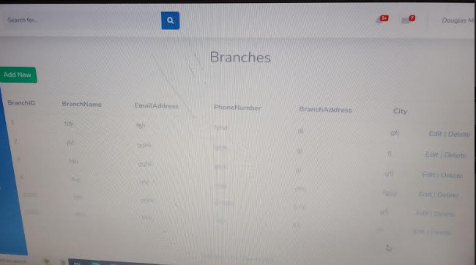

* Admin can manage Services of the web-application.

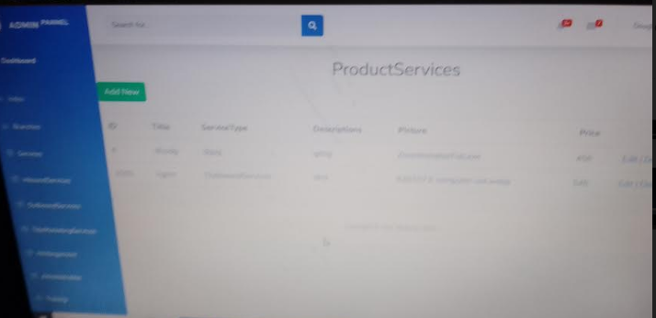

* Here, are some SERVICES which can also be managed by admin.

**INBOUNDSERVICES**

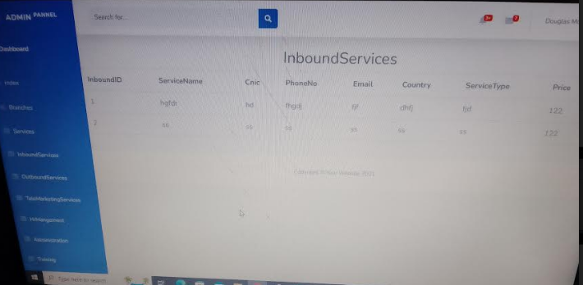

**OUTBOUNDSERVICES**

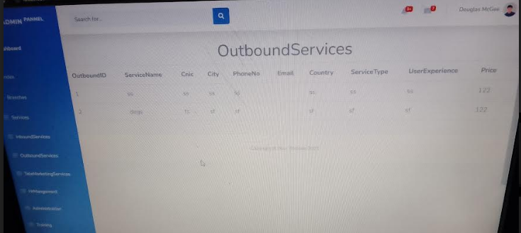

**TELEMARKETING**

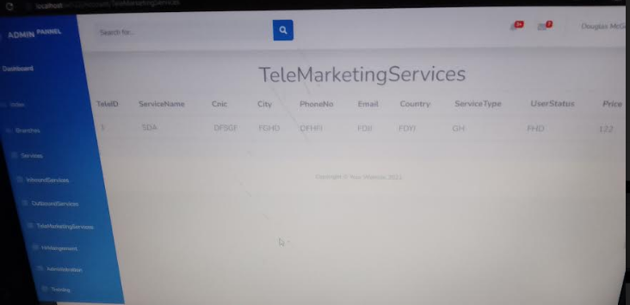

* Now we have Address Management

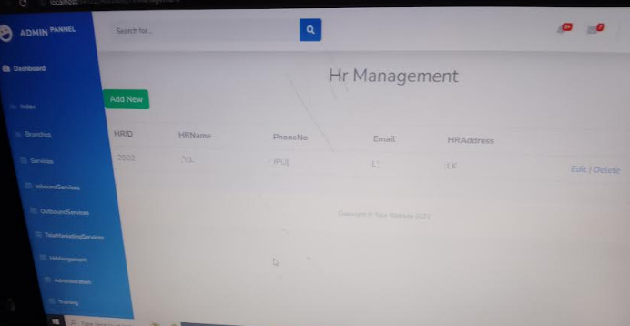

* Now we have Admi Training page

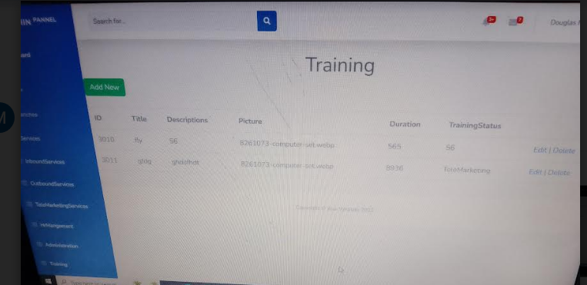

The Home Page Over view.

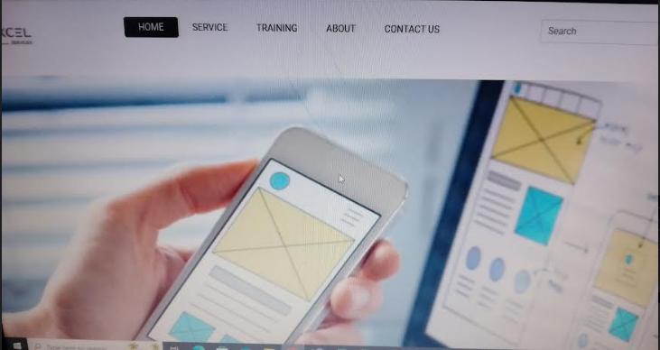

Home Page Navigation:



CONTACT PAGE

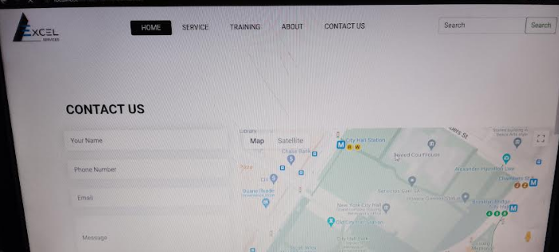

HERE IS TRAINING PAGE:

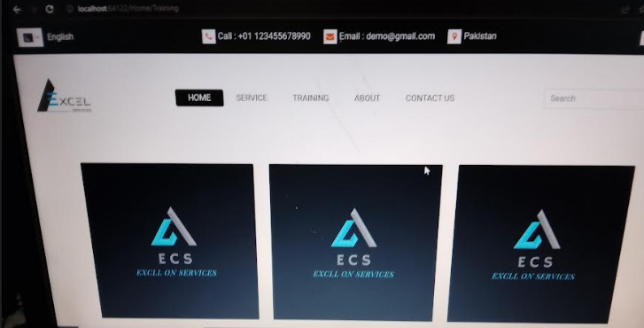

SERVICES PAGE:

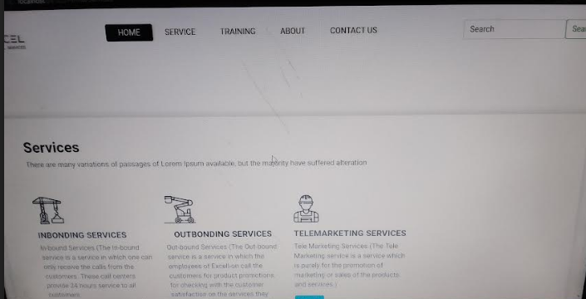

# **7. Task Sheet**

|  |  |  |
| --- | --- | --- |
| **Date** | **Task** | **Resource** |
| 5July 2023 – 26 July2023 | Frontend + Backend | Whole team members |

# **8. Source Code**

* Login code

Login authentication plays a very special role in every application and portal, that’s why we program a very secured and authentic logic for our web application. Admin and Users both have separate login access

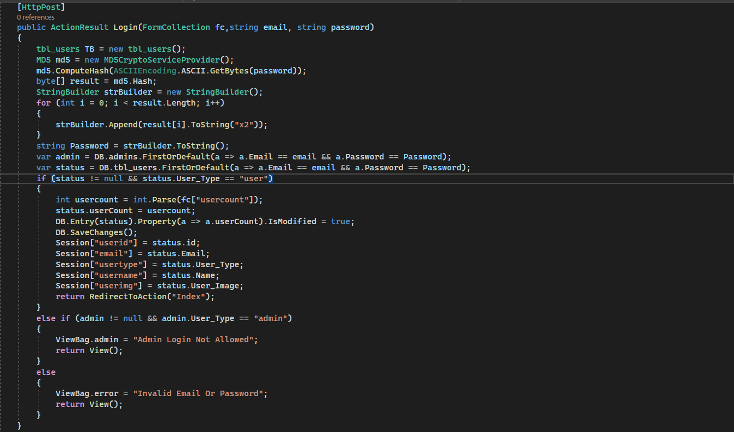

* Logout using (AJAX) code,

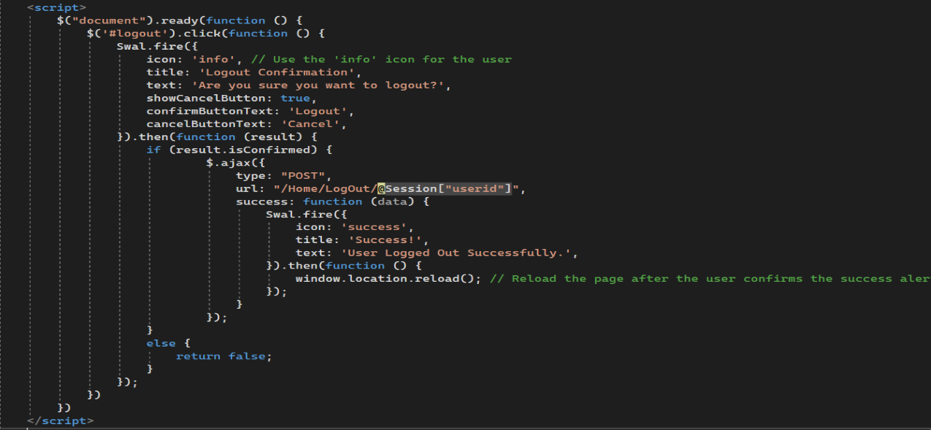

controller code, whenever user logout his/her account, their logged in count will be updated as (int) type 0.

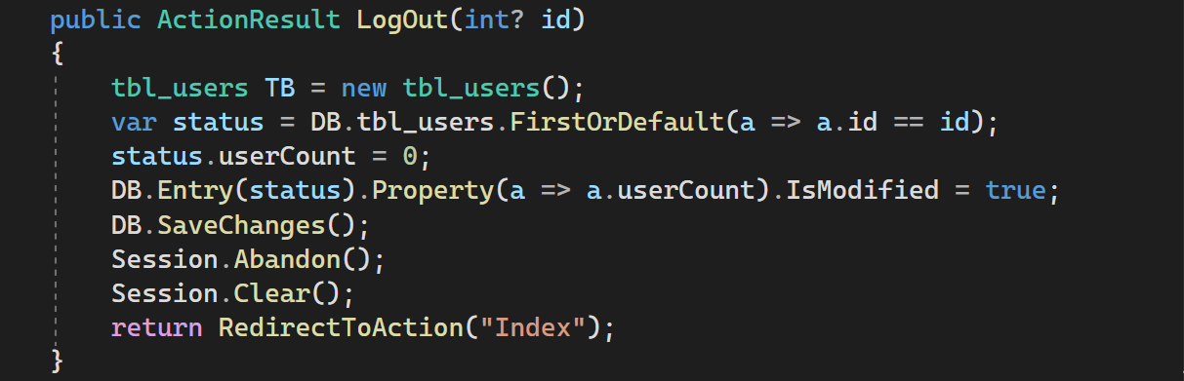

* 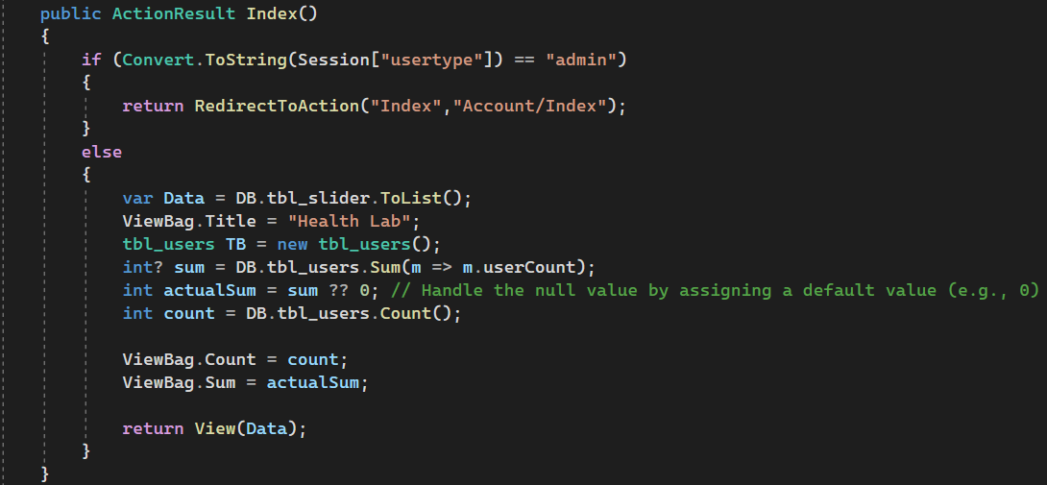Logged in and Registered user’s count code.

Web forums Add Query controller’s code

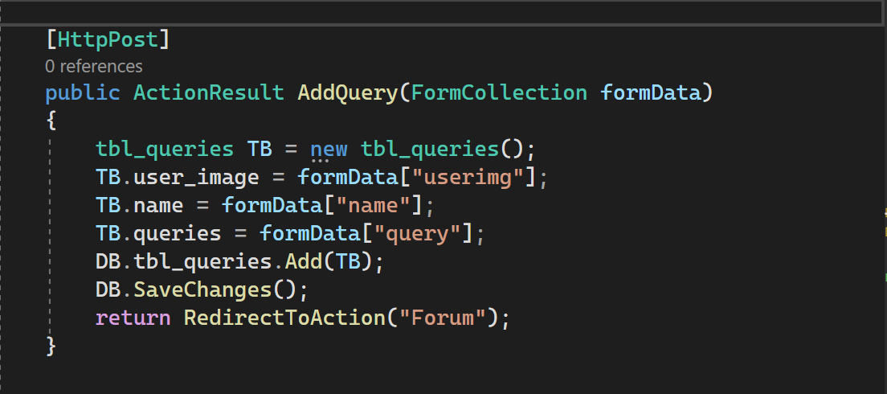

* Web Forum’s Add CODE OR DELETE CODE

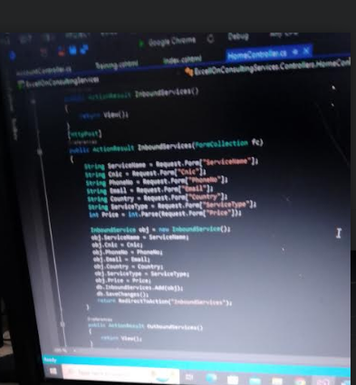

# **9. Unit Testing Check List**

|  |  |
| --- | --- |
| **Doctors Web Forum** | |
| Organization Name | Health Lab |
| Login | Successfully Working |
| Account Registration | Successfully Working |
| Advanced Search Bar | Successfully Working |
| User’s Profile Privacy | Successfully Working |
| User’s Profile Management | Successfully Working |
| Web Forum Posting Query | Successfully Working |
| Web Forum Posting Replies | Successfully Working |
| Form Validations | Successfully Working |
| Logged In Count | Successfully Working |
| Registered Count | Successfully Working |
| Sweet Pop-up Windows | Successfully Working |
| Separate Admin Login | Successfully Working |
| User’s Management by Admin | Successfully Working |
| Full Web’s Dynamic Data Retrieving | Successfully Working |
| Web’s Appointment Form | Successfully Working |
| Web’s Contact Form | Successfully Working |

# **1. Final Check List**

All the requirements specified by customer has been checked.

**THANK YOU**